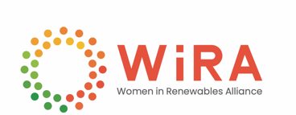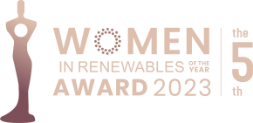

5th WOMEN IN RENEWABLES OF THE YEAR AWARDS

2023 APPLICATION FORM
In conjunction with Women in Renewables Gala Night
March 15 2023 | Palazzo Versace Dubai, UAE

First name |  |  | Last name |  | Nationality
Company
Company category |  |  |  | Title
Phone |  |  |  | Email

Reminder: the nominees will be ranked on the following criteria:
- Presentation: Format and quality of description and presentation
- Degree of Technological Innovation: Technological advancement; Technological creativity and quality; Singularity in comparison with other solutions
- Proof of Dedication: Foresight and dedication in energy transition

Please attached your power point presentation regarding to the accomplishments of the company/organization in the relevant renewable energy market, including:
- Your self-introduction (name, organization, title, photo)
- Major recent accomplishments
- Highlighted career stories

Please submit the application to molly@womeninrenewables.org
If you have any questions, please contact via +86 156 0177 4853

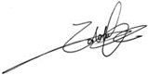
Molly Huang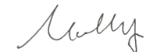 Eddie Lee
Executive Secretary Managing Director
Women in Renewables Alliance CGHM Organizing Committee

